4th Annual Literacy Fair

What is the Literacy Fair?

- It gives you the opportunity to share one of your favorite books with the rest of the school by creating a storyboard about a book that you have read.
- Completed storyboards will be displayed in each homeroom class.
- The top two storyboards in each homeroom will be displayed in the fair that will take place in the library during Read Across America Week, which starts March 2nd.
- Voting will take place throughout the week by a team of judges. Ribbons will be placed on the winning projects at the end of that week.
- All projects will also count as a Language Arts class grade.
What you have to do:

- Select a book and create a storyboard telling the main points about the book (see included checklist & outline). This may be a book that you have read this year (not for class) or a new book you plan to read.
- Choose a book. It can be a book you already read this year! You can use the book towards Books & Beyond.
- Check the book out from school, the public library or purchase it.
- Complete the outline as you read. (This does not need to be turned in.)
- Create a storyboard following the requirements and turn in on the due date for your grade.

Your book: Must be appropriate to your age & reading ability. Check with your ELA teacher or Mrs. Motyka if you aren’t sure about your book choice. Choose a book that is on your level (not too easy or too difficult)

Grade 4:
- Must be fiction
- Students cannot select a graphic novel for the project, but, they may choose a “Diary of a Wimpy Kid” style novel (For Example: Dork Diaries, Captain Underpants). No “Who Was” books.

Grade 5: No graphic novels or “Diary of a Wimpy Kid” style books (For Example: Dork Diaries, Captain Underpants). No “I Survive” books will be permitted.

Grade 6: Only age appropriate novels (no graphic novels) – please check with ELA teacher or Library Media Specialist is unsure about a particular book

Your Storyboard:

- A standard tri-fold project board that unfolds to be no bigger than 36” H x 48” W.
- Use the accompanying checklist as a guide to help when creating the project.
- Models, shadowboxes, and illustrations that fit in the middle of the display are allowed.
- Your name, grade level, and homeroom teacher’s name should be labeled on the back of the storyboard.
- Items on the boards may be handwritten or typed.
- Winning projects are often those that are clearly student created with bright, colorful and neat illustrations or words.

You may check the Pierrepont School Library website (http://pierrepontschool-library.weebly.com ) for a PowerPoint presentation on the project, judging rubrics, extra copies of outlines, and pictures of sample storyboards.

Checklist of Required Story Elements for a Fiction Book
_______ Title
_______ Author
_______ Publisher and Publication Date
_______ Setting (place and time of story)
_______ Main Characters (What characters are important to the story line?) (Why are those characters important to
the story?)
_______ Plot Summary (What is a brief summary of what the story is about and what takes place?)
_______ Conflict (What is the problem in the story?)
_______ Solution or Resolution (How is the problem resolved?)
_______ Author’s Purpose (Why did the author write the story?… to entertain, inform, persuade, or a combination)
_______ Tone or Mood (The tone affects the feelings of the reader or how the author wants the reader to feel when
reading the story. What is the tone and the mood of the story?).
_______ Why did you choose to do a project on the book or text?

Writing:
- Writing is neat and inviting.
- Writing is easily understood.

Creativity:
- Project is original.
- Project demonstrates imagination.
- Unique materials are used to express ideas.

Quality of Project:
- Project follows the guidelines.
- Project is durable and will last through several rounds of competition without physical support.

Thoroughness of Written Information:
- Project captures the most important information.
- Project captures the concept/point the author made in the book.

Interest Evoked:
- Project demonstrates student’s ability.
- Project encourages others to read the book.
- Project attracts others and makes them interested in the work.

Sample Fiction Storyboard:

This is just a sample of how to put together a storyboard to help you get started and to help you make sure you have all the elements for a Reading Project.

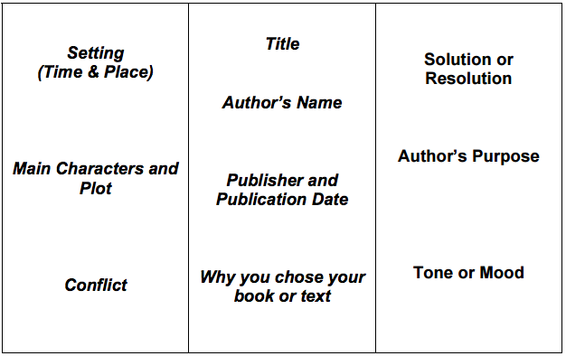

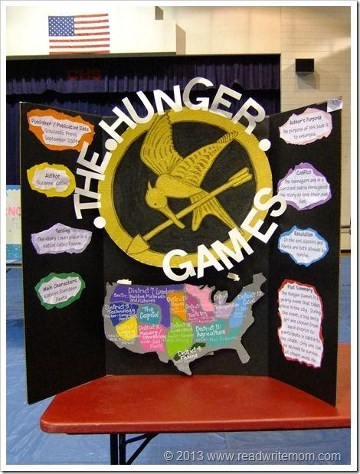

Checklist of Required Non-fiction Elements

_______ Title
_______ Author
_______ Publisher and Publication Date
_______ Student prediction based on events and facts presented (What do you think this book will be about
before reading it? Feel free to use a KWL graphic organizer.)
_______ Structure of text / Genre (What is the genre of the text? How do you know?)
_______ Main Idea [Use of graphic organizers (including, but not limited to: compare/contrast, cause/effect,
problem solving) to capture the main idea and /or main points that are important to the text]
_______ Summary-brief summary (50 words or less, not word-for-word retelling) about the book.
_______ Student-made connections (text-to-self, text-to-text, and/or text-to-world)
_______ Author's Purpose - Why did the author write the story? (entertain, inform, persuade, or a combination)
_______ Follow-up questions to the author after reading the non-fiction text.
_______ Why did you choose to do a project on the book or text?
The six main genres of non-fiction are:

1. Instructional: used to describe how something is done or made.
2. Explanatory: tells what happened or how something works, with defined reasons.
3. Report: tells how things are or are discovered.
4. Discussion: looks at both sides of an idea and makes a decision.
5. Opinion: decides on a point-of-view and has reasons to support the view.
6. Relate: retells the information or events for an audience.

Writing:
- Writing is neat and inviting.
- Writing is easily understood.

Creativity:
- Project is original.
- Project demonstrates imagination.
- Unique materials are used to express ideas.

Quality of Project:
- Project follows the guidelines.
- Project is durable and will last through several rounds of competition without physical support.

Thoroughness of Written Information:
- Project captures the most important information.
- Project captures the concept/point the author made in the book.

Interest Evoked:
- Project demonstrates student’s ability.
- Project encourages others to read the book.
- Project attracts others and makes them interested in the work.

Sample Non-fiction Storyboard

This is just a sample of how to put together a storyboard to help you get started and to help you make sure you
have all the elements for a Reading Project.

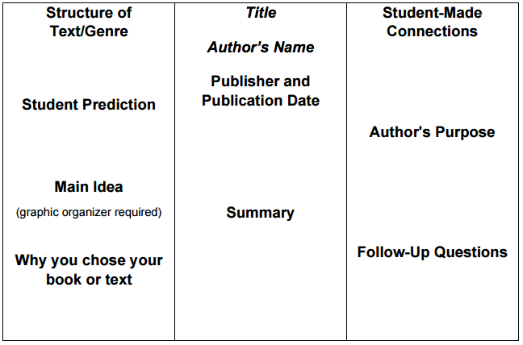

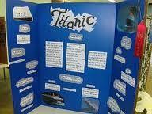

Literacy Fair Project Outline – Fiction

TITLE

What is the title of the book?

_________________________________________________________________________________________________________________________

AUTHOR

Who wrote the book? If there is an illustrator, who is the illustrator?

_________________________________________________________________________________________________________________________

PUBLISHER and PUBLICATION DATE

What is the name of the company who published the book? When was the book published?

Consult the copyright page on the back of the title page for the publishing information.

_________________________________________________________________________________________________________________________

_________________________________________________________________________________________________________________________

MAIN CHARACTERS

Who are the most important characters in the story? Why are those characters important?

_________________________________________________________________________________________________________________________

_________________________________________________________________________________________________________________________

_________________________________________________________________________________________________________________________

_________________________________________________________________________________________________________________________

_________________________________________________________________________________________________________________________

SETTING

When and where does the story take place?

_________________________________________________________________________________________________________________________

_________________________________________________________________________________________________________________________

_________________________________________________________________________________________________________________________

_________________________________________________________________________________________________________________________

_________________________________________________________________________________________________________________________

PLOT SUMMARY

Briefly summarize what the story is about and what takes place. Use your own words.

_________________________________________________________________________________________________________________________

_________________________________________________________________________________________________________________________

_________________________________________________________________________________________________________________________

_________________________________________________________________________________________________________________________

_________________________________________________________________________________________________________________________

_________________________________________________________________________________________________________________________

_________________________________________________________________________________________________________________________

_________________________________________________________________________________________________________________________

_________________________________________________________________________________________________________________________

_________________________________________________________________________________________________________________________

CONFLICT

What is the problem in the story?

_________________________________________________________________________________________________________________________

_________________________________________________________________________________________________________________________

_________________________________________________________________________________________________________________________

_________________________________________________________________________________________________________________________

_________________________________________________________________________________________________________________________

SOLUTION or RESOLUTION

How was the problem resolved?

_________________________________________________________________________________________________________________________

_________________________________________________________________________________________________________________________

_________________________________________________________________________________________________________________________

_________________________________________________________________________________________________________________________

_________________________________________________________________________________________________________________________

AUTHOR’S PURPOSE

Why did the author write the story? (to entertain, to inform, or to persuade?)

_________________________________________________________________________________________________________________________

_________________________________________________________________________________________________________________________

_________________________________________________________________________________________________________________________

_________________________________________________________________________________________________________________________

_________________________________________________________________________________________________________________________

TONE or MOOD

How does the author want the reader to feel while reading the story?
_________________________________________________________________________________________________________________________

_________________________________________________________________________________________________________________________

_________________________________________________________________________________________________________________________

_________________________________________________________________________________________________________________________

_________________________________________________________________________________________________________________________

Why did you choose to do a project on the book or text?

_________________________________________________________________________________________________________________________

_________________________________________________________________________________________________________________________

_________________________________________________________________________________________________________________________

_________________________________________________________________________________________________________________________

_________________________________________________________________________________________________________________________

Literacy Fair Project Outline – Nonfiction

TITLE

What is the title of the book?

_________________________________________________________________________________________________________________________

AUTHOR

Who wrote the book? If there is an illustrator, who is the illustrator?

_________________________________________________________________________________________________________________________

PUBLISHER and PUBLICATION DATE

What is the name of the company who published the book? When was the book published?

Consult the copyright page on the back of the title page for the publishing information.

_________________________________________________________________________________________________________________________

_________________________________________________________________________________________________________________________

PREDICTION

Before you read, make a prediction based on the events and facts that are presented. After

reading, discuss if your prediction was correct or incorrect and why.
_________________________________________________________________________________________________________________________

_________________________________________________________________________________________________________________________

_________________________________________________________________________________________________________________________

_________________________________________________________________________________________________________________________

_________________________________________________________________________________________________________________________

_________________________________________________________________________________________________________________________

_________________________________________________________________________________________________________________________

_________________________________________________________________________________________________________________________

_________________________________________________________________________________________________________________________

_________________________________________________________________________________________________________________________

STRUCTURE OF TEXT/GENRE

Was your book a discussion, a report, explanatory, opinion, instructional, or relate. Include a

graphic organizer of your book on your project board.

_________________________________________________________________________________________________________________________

_________________________________________________________________________________________________________________________

_________________________________________________________________________________________________________________________

_________________________________________________________________________________________________________________________

_________________________________________________________________________________________________________________________

SUMMARY

Briefly summarize what the book is about. Use your own words.

_________________________________________________________________________________________________________________________

_________________________________________________________________________________________________________________________

_________________________________________________________________________________________________________________________

_________________________________________________________________________________________________________________________

_________________________________________________________________________________________________________________________

_________________________________________________________________________________________________________________________

_________________________________________________________________________________________________________________________

_________________________________________________________________________________________________________________________

_________________________________________________________________________________________________________________________

_________________________________________________________________________________________________________________________

STUDENT-MADE CONNECTIONS

Make connections from the information in the book to yourself and your life, to other books,
and/or to things in the real world.

_________________________________________________________________________________________________________________________

_________________________________________________________________________________________________________________________

_________________________________________________________________________________________________________________________

_________________________________________________________________________________________________________________________

_________________________________________________________________________________________________________________________

AUTHOR’S PURPOSE

Why did the author write the story? (To entertain, to inform, or to persuade?)

_________________________________________________________________________________________________________________________

_________________________________________________________________________________________________________________________

_________________________________________________________________________________________________________________________

_________________________________________________________________________________________________________________________

_________________________________________________________________________________________________________________________

FOLLOW-UP QUESTIONS

What questions would you have for the author after reading this story?

_________________________________________________________________________________________________________________________

_________________________________________________________________________________________________________________________

_________________________________________________________________________________________________________________________

_________________________________________________________________________________________________________________________

_________________________________________________________________________________________________________________________

Why did you choose to do a project on the book or text?

_________________________________________________________________________________________________________________________

_________________________________________________________________________________________________________________________

_________________________________________________________________________________________________________________________

_________________________________________________________________________________________________________________________

_________________________________________________________________________________________________________________________

